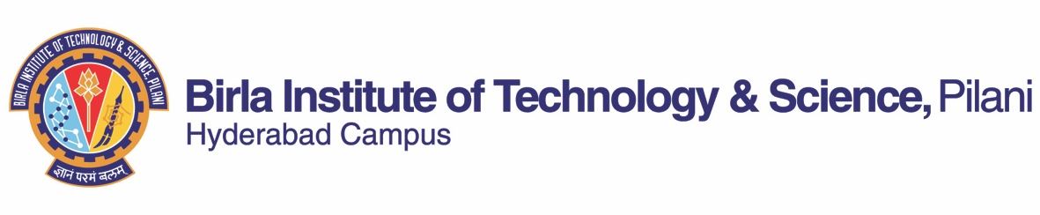

**FIRST SEMESTER 2019-2020**

# Course Handout Part II

Date: 20-07-2019

In addition to part-I (General Handout for all courses appended to the time table) this portion gives further specific details regarding the course.

*Course No.* : *CS G525*

## Course Title : Advanced Computer Networks

## Instructor-in-Charge : Dr. Paresh Saxena (psaxena@hyderabad.bits-pilani.ac.in)

**Scope of the Course:**

This course is an advanced computer networking course focusing on the relevant and state-of-the-art networking protocols and architectures. The focus is on the protocols used in the modern networked systems including wireless and mobile networks. The goals of the course is to build on basic networking course material in providing a deep understanding of existing technology with concrete experience of the challenges through a series of lab exercises. The course is divided into four parts where the first three parts aim to provide deep understanding of protocols, architectures and segment structures at different layers of the protocol stack specifically transport, network and link layers. The final part is designed to provide a comprehensive understanding and evolution of the wireless network.

**Objectives of the Course:**

* To understand the state-of-the-art networking protocols at different layers of the protocol stack.
* To develop a strong understanding of the core concepts of computer networks.
* To gain experience in research oriented activities where the lab is designed for students to gain practices of reading research papers, design experiments, perform analysis and presentation of results.
* To gain hands-on experience with the networking protocols.

**Textbooks:**

[T1] James F. Kurose and Ross, Computer networking: a top-down approach featuring the Internet, 6th Ed., Pearson, 2016.

**Reference Books:**

[R1] L. L. Peterson B.S. Davie, “Computer Networks: A Systems Approach”, 5 th Ed., Morgan Kaufmann, Elsevier, 2012.

[R2] A S Tanenbaum, Computer Networks, 5th Ed, Pearson, 2013.

**Course Plan:**

|  |  |  |  |  |
| --- | --- | --- | --- | --- |
| **S.. No.** | **No. of Lectures** | **Learning objectives** | **Topics to be covered** | **Chapter in the Text Book** |
| 1 | 1 | - To understand the course components and structure. | Basic introduction to the course, explanation of exams and evaluations, lab project, etc. | Class Notes |
| **PART A: TRANSPORT LAYER** | | | | |
| 2 | 1 | - To understand the basics of User Datagram Protocol (UDP) | UDP protocol, UDP segment structure, UDP checksum. | T1: Chapter 3,  Class Notes |
| 3 | 1 | - To learn reliable data transfer protocols | Go-Back-N and Selective Repeat protocols | T1: Chapter 3,  Class Notes |
| 4 | 5 | -To understand the basics of TCP and TCP variants | TCP connection, TCP segment structure, round trip time, understanding congestion, congestion control algorithms, TCP variants, Fairness | T1: Chapter 3,  Class Notes |
| 5 | 5 | - To learn modern transport layer protocols | SPDY, QUIC and Multipath TCP (MPTCP) | Class Notes |
| **PART B: NETWORK LAYER** | | | | |
| 6 | 3 | -To introduce network layer and network service models | CBR ATM network service, ABR ATM network service, routers, queueing. | T1: Chapter 4,  Class Notes |
| 7 | 5 | - To understand the Internet Protocol (IP) | IP datagram, IPv4 addressing, NAT, IPv6. | T1: Chapter 4,  Class Notes |
| 8 | 5 | - To understand routing algorithms | Link-State (LS), Distance-Vector (DV), Hierarchical routing, RIP, OSPF, BGP, Broadcast routing algorithms, multicast routing algorithms. | T1: Chapter 4,  Class Notes |
| **PART C: LINK LAYER** | | | | |
| 9 | 2 | - To introduce link layer and error detection technqiues. | Link layer services, error detection and correction techniques, | T1: Chapter 5,  Class Notes |
| 10 | 3 | - To learn link layer protocols | Channel partitioning protocols, random access protocols, DOCSIS | T1: Chapter 5,  Class Notes |
| 11 | 3 | - To understand local area networks | Link-layer addressing, ARP, Ethernet, Link layer switching, VLANs, MPLS | T1: Chapter 5,  Class Notes |
| **PART D: WIRELESS NETWORKS** | | | | |
| 12 | 3 | - To understand wireless LAN architectures and protocols | Single-hop, Multi-hop infrastructures, IEEE 802.11 architecture and protocol, Bluetooth, Zigbee | T1: Chapter 6,  Class Notes |
| 13 | 5 | - To understand Cellular Internet Access | 2G, 3G and 4G cellular data networks, Introduction to 5G: current status and future | Class Notes |
|  | **Total number of Lectures: 42** |  |  |  |

**Evaluation Scheme:**

|  |  |  |  |  |
| --- | --- | --- | --- | --- |
| **Component** | **Duration** | **Weightage (%)** | **Date & Time** | **Nature of Component** |
| Mid-Semester Exam | 90 Mins | 20% | 01/10 , 01:30 – 03:00 p.m. | Closed Book |
| Lab/Term Project  (weekly evaluation) | - | 15% | Details will be announced during 2nd week of August. | Open Book/Take Home |
| Lab/Term Project (Report) | - | 10% | - | Open Book/Take Home |
| Lab/Term Project (Presentation) | - | 15% | - | Open Book/Take Home |
| Comprehensive Exam | 3 hrs. | 40% | 7th December 2019 | Closed Book. |

**Chamber Consultation Hour:** To be announced in class.

**Notices:** All notices pertaining to this course will be displayed on the CS&IS Notice Board or CMS.

**Make-up Policy:**

* **No Make-ups for Quizzes or weekly evaluation under any circumstances.**
* Prior permission of the Instructor-in-Charge is required to get make-up for the Mid-Sem. Only on producing documentary proof of possible absence, which proves that student would be physically unable to appear for the exam, the decision of granting the make-up will be taken.
* Prior permission of Dean, Instruction Division is required to get for the make-up of the comprehensive exam. Instructor-in-charge’s/Dean’s decision in the matter of granting make-up would be final.

**Academic Honesty and Integrity Policy:** Academic honesty and integrity are to be maintained by all the students throughput the semester and no type of academic dishonesty is acceptable.

**INSTRUCTOR-IN-CHARGE**